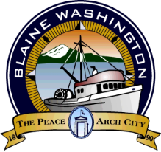

PUBLIC WORKS AND PARK ADVISORY BOARD

TUESDAY, MAY 6, 2025

MINUTES

CALLED TO ORDER: 9:02 AM

ROLL CALL: Samantha Childers, Dennis Olason, Mike Lucas, Jacob Soileau, Sandy Miller

BLAINE STAFF: Gary McSpadden

MEETING MINUTES: Six vote “yes” moved to approve March’s meeting minutes, which passed unanimously.

M+O UPDATES:
- Discussed the downtown revitalization project, including permit status and tentative start time. We discussed the project's scope, including all concrete work, landscaping, lighting, and moving four fire hydrants.
- Discussed the 2026-2031 TIP – Harpiar gave the purpose of the TIP and that it must be presented to the County by June 26, 2025
Public Works Updates:
1. 2 Picnic tables to go to Lincoln Park
2. Check the signage for the frisbee golf course at Lincoln Park
3. PW will share the 2025 road assessment with the board when completed.
4. Dennis asked to check the visibility of traffic entering Mitchell St. from Georgia. Also mentioned, there were no pedestrian signs on Georgia St.
5. Discussed possible chip sealing on Jerome this year, as the funds allow
6. Update on Marine Park build status.
The group did not want to vote for a new chair; they opted to leave Mike Lucas as Vice Chair for the time being

MEETING ADJOURNED: 9:45 AM

