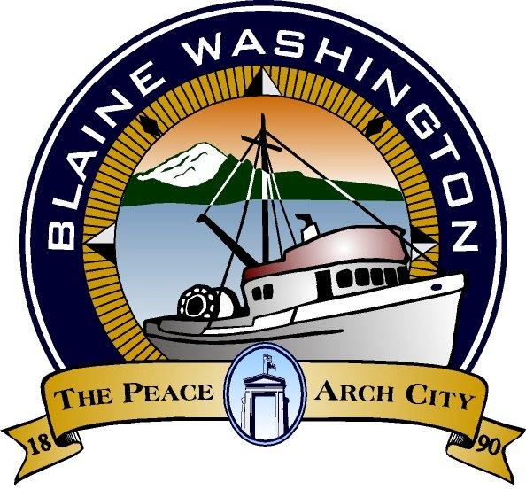

344 H Street, Blaine WA 98230

CITY COUNCIL
WORKSESSION

MONDAY, November 15, 2004

5:15 PM

Ken Ely – MAYOR PRO- TEM

A. CALL TO ORDER:

B. ROLL CALL:

C. BUSINESS

- West Blaine Treatment Alternatives and Costs

D. ADJOURN

