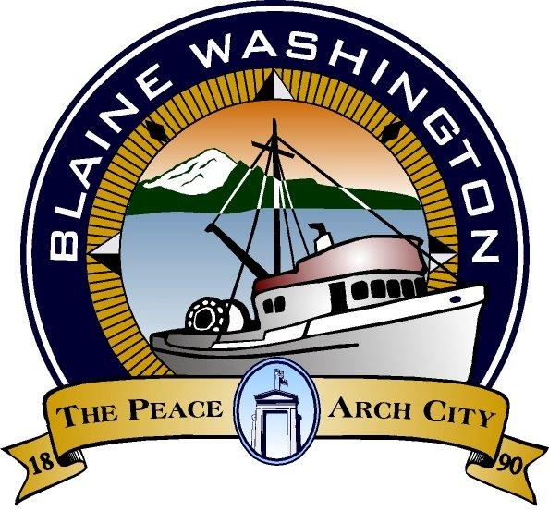

344 H Street, Blaine WA 98230

CITY COUNCIL
WORKSESSION

MONDAY, October 25, 2004

6:00 PM

JOHN LIEBERT – MAYOR PRO- TEM

A. CALL TO ORDER:

B. ROLL CALL:

C. BUSINESS

- Appeal to Growth Hearing Board

- CBD – A review of emergent development issues.

D. ADJOURN

