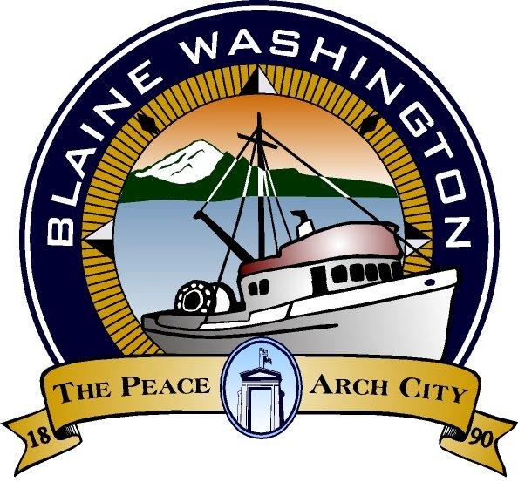

344 H Street, Blaine WA 98230

CITY COUNCIL
WORKSESSION

MONDAY, May 3, 2004

5:15 PM

JOHN LIEBERT – MAYOR PRO- TEM

A. CALL TO ORDER:

B. ROLL CALL:

C. BUSINESS

- 2005 - 2010 Transportation Improvement Plan (TIP)

- I-5 Exit 274 Interchange Access Point Decision Report Update

D. ADJOURN

