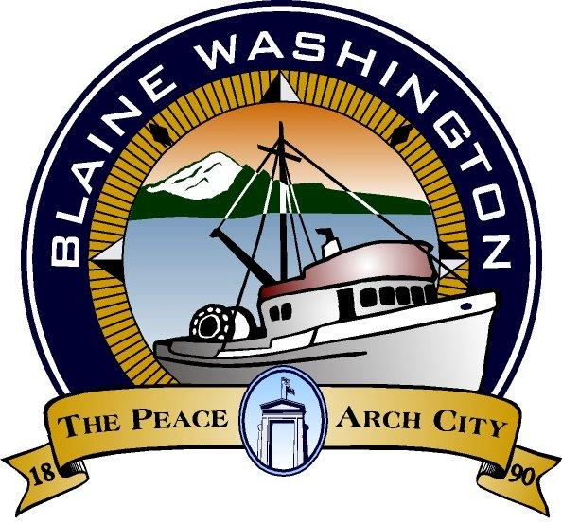

344 H Street, Blaine WA 98230

SPECIAL CITY COUNCIL MEETING

MONDAY, October 18, 2004

5:15 PM

JOHN LIEBERT – MAYOR PRO- TEM

A. CALL TO ORDER:

B. ROLL CALL:

C. BUSINESS

- Interview Council Candidates 5:30 p.m.

  - Bob Brunkow 5:30 p.m.

  - Thomas Drake 6:00 p.m.

      - Appointment of City Council Position for Ward 3

D. ADJOURN

