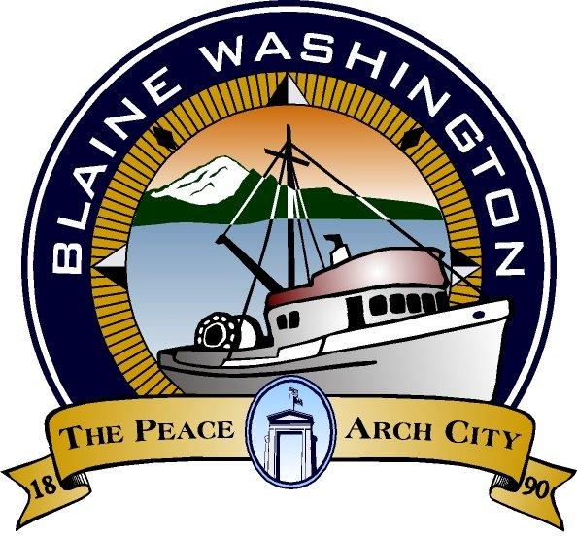
CITY OF BLAINE
344 H Street
Blaine, WA 98230
CITY COUNCIL AGENDA

MONDAY, June 14, 2004

- NOTE: WORKSESSION - General Sewer Plan and Preliminary Environmental Report Marine Drive - 5:15 P.M.

- EXECUTIVE SESSION:

B. CALL TO ORDER

C. INVOCATION – MOMENT OF SILENCE

- PLEDGE OF ALLEGIANCE

E. ROLL CALL:

- STAFF PRESENT:

F. AUDIENCE PARTICIPATION

- Thank you Letters for: Blaine/Bay Refuse Jim Sands; John Teela; Leonard Johnston; and Garret Kerr

- Thank you Letters for City of Blaine Volunteers: Leo Baldwin; Rod Smith Jon Walter; Mike Schrader; Leroy Dougall and Sandy Petersen

- Proclamation - 60th Anniversary Local Veterans Employment Representative Program (G.I. Bill)

- Proclamation - Christina Alexander

G. CITY MANAGER AND STAFF REPORTS

- Police Department Projects Update - Chief Haslip

H. MAYOR’S REPORT

I. WRITTEN COMMUNICATION

  - CONSENT AGENDA
Items listed below have been distributed to Council-members in advance for study and will be enacted by one motion. If separate discussion is desired on an item, that item may be removed from the Consent Agenda and placed on the Regular Agenda at the request of a Council-member.

- Approval of Bills - Amount: $

- Approval of May Payroll: $352,130.72

- Approval of May 24 2004 City Council Minutes

- Approval of Resolution 1376-Declaring certain Public Works vehicles and equipment surplus property

- Approval of Ordinance No. 04-2580 Budget for various City Funds

  - PUBLIC HEARING (MEETING)
*PLEASE NOTE: Persons speaking on any issue will be allowed three (3) minutes. An additional two (2) minutes of non-repetitive testimony will be allowed after all testimonies have been heard

- Six-Year Transportation Improvement Program 2005 - 2010
(Close Public Hearing)

L . UNFINISHED BUSINESS

1. Resolution No. 1377-04 Six-Year Transportation Improvement Program(TIP) 2005 - 2010. Refer to June 28, 2004 Council Agenda

- NEW BUSINESS

- Amendment to CH2M Hill Contract for Marine Drive Water Reclamation Facility Plan. First Reading

- Marine Drive Preliminary Environmental Report.

- City/BBWSD Memorandum of Understanding to Establish Temporary Water Distribution System Intertie - First Reading.

- Wastewater Treatment Plant Interim Improvements - Professional Service Agreement. First Reading.

- Port of Bellingham Economic Development Funding Interlocal Agreement. First Reading.

N.COUNCIL MEMBERS AND ADVISORY COMMITTEE REPORTS

O. FURTHER BUSINESS

- EXECUTIVE SESSION - NONE

- ADJOURN

Americans with Disability Act (ADA) Requirement: The meeting location is accessible. If you require a special accommodation during your attendance at any public meeting, please contact the City Clerk (360) 332-8311, 7 – 10 days prior to the meeting date you will be attending. Thank you.

