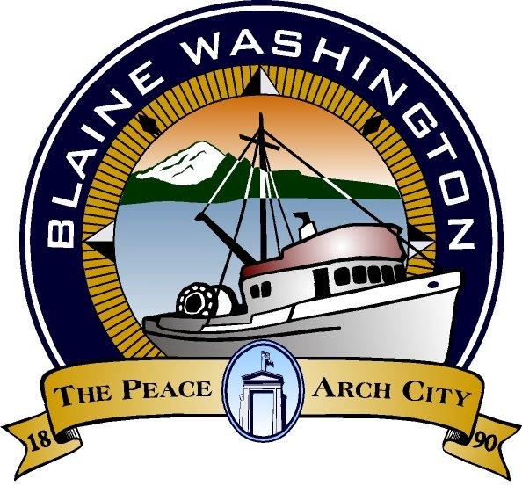
CITY OF BLAINE
344 H Street
Blaine, WA 98230
CITY COUNCIL AGENDA

MONDAY, MAY 24, 2004

NOTE: WORKSESSION - PARK - PLAN 5:15 P.M.

- EXECUTIVE SESSION:

B. CALL TO ORDER

C. INVOCATION – MOMENT OF SILENCE

- PLEDGE OF ALLEGIANCE

E. ROLL CALL:

- STAFF PRESENT:

F. AUDIENCE PARTICIPATION

- Representative Doug Erickson

G. CITY MANAGER AND STAFF REPORTS

- Seafood Processors Update - Steve Banham
- Outfall Repairs Update - Steve Banham
- Border Sector Headquarters Update - Steve Banham
- Moratorium on Land Use Development Staff Report - Terry Galvin

H. MAYOR’S REPORT

I. WRITTEN COMMUNICATIONS

  - CONSENT AGENDA
Items listed below have been distributed to Council-members in advance for study and will be enacted by one motion. If separate discussion is desired on an item, that item may be removed from the Consent Agenda and placed on the Regular Agenda at the request of a Council-member.

- Approval of Bills - Amount: $

- Approval of Payroll: $ NONE

- Approval of May 10, 2004 City Council Minutes

  - PUBLIC HEARING (MEETING)
*PLEASE NOTE: Persons speaking on any issue will be allowed three (3) minutes. An additional two (2) minutes of non-repetitive testimony will be allowed after all testimonies have been heard

- Six-Year Transportation Improvement Program 2005 - 2010

L. UNFINISHED BUSINESS

  - NEW BUSINESS

- Consultant Amendment for Semiahmoo Express Feeder. First Reading

  - COUNCIL MEMBERS AND ADVISORY COMMITTEE REPORTS

  - FURTHER BUSINESS

- Note: Work Session June 1, 2004 5:15 Environmental Report on Marine Park

  - EXECUTIVE SESSION - NONE

  - ADJOURN

Americans with Disability Act (ADA) Requirement: The meeting location is accessible. If you require a special accommodation during your attendance at any public meeting, please contact the City Clerk (360) 332-8311, 7 – 10 days prior to the meeting date you will be attending. Thank you.

