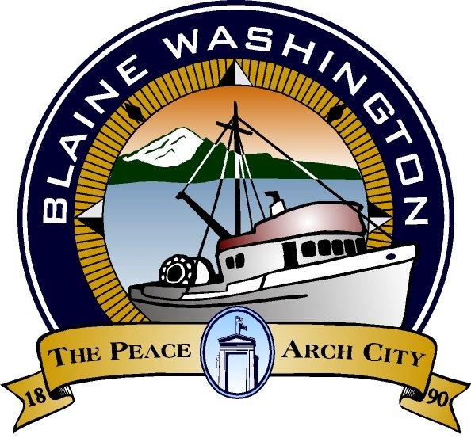
CITY OF BLAINE
344 H Street
Blaine, WA 98230
CITY COUNCIL AGENDA
Monday, May 10, 2004, 7:00 PM

NOTE: Joint WORK SESSION 5:15p.m.- Continue Discussion of Comp-plan with City Council/Planning Commission.

- EXECUTIVE SESSION: -

- CALL TO ORDER

- INVOCATION – MOMENT OF SILENCE

- PLEDGE OF ALLEGIANCE

- ROLL CALL:

- STAFF PRESENT:

B. AUDIENCE PARTICIPATION

- 2003 Service Awards:
5 Years Luanne Cranefield - Probation Officer
5 Years Debra Hertz - Police Officer
5 Years Leo Baldwin - Maintenance Worker

15 Years Doug Balmer - Senior Police Officer

.20 Years Clifford Ness - Wastewater Treatment Plant Lead Operator

25 Years Shirley Thorsteinson - City Clerk/Personnel

C. CITY MANAGER AND STAFF REPORTS

- Law and Justice Report - Barbara Schugt

- Report of Blaine's Work Day Extravaganza: Clean-up Day; 6th Street Tree Planting and Salishan and Kilmer Park clean-up.

- Initiative 864 Introduction

- Adelia Commons Access - Report
-
D. MAYOR’S REPORT

E. WRITTEN COMMUNICATIONS

F. CONSENT AGENDA
Items listed below have been distributed to Council members in advance for study and will be enacted by one motion. If separate discussion is desired on an item, that item may be removed from the Consent Agenda and placed on the Regular Agenda at the request of a Council member.

- Approval of Bills - Amount

- Approval of April Payroll: $:345,319.97

- Approval of April 26, 2004 City Council Minutes

- Approval of Proclamation for Native Plant Appreciation Week

G. PUBLIC HEARING (MEETING)
*PLEASE NOTE: Persons speaking on any issue will be allowed three (3) minutes. An additional two (2) minutes of non-repetitive testimony will be allowed after all testimonies have been heard

NONE

H. UNFINISHED BUSINESS

I. NEW BUSINESS
-
- -Ordinance No. 04-2575 New Sit Plan Regulations for the City's Land Use and Development Code - Title 17 BMC - First Reading

  - COUNCIL MEMBERS AND ADVISORY COMMITTEE REPORTS

  - FURTHER BUSINESS

- Work session Monday, May 17, 2004 5:30 p.m. City Council Staff Performance Evaluation
- Work session Monday, May 24, 2004 5:15 p.m. Parks Plan
- Work session Tuesday, June 1, 2004 5:15 p.m. General Sewer Plan

  - EXECUTIVE SESSION - NONE

  - ADJOURN

Americans with Disability Act (ADA) Requirement: The meeting location is accessible. If you require a special accommodation during your attendance at any public meeting, please contact the City Clerk (360) 332-8311, 7 – 10 days prior to the meeting date you will be attending. Thank you.

