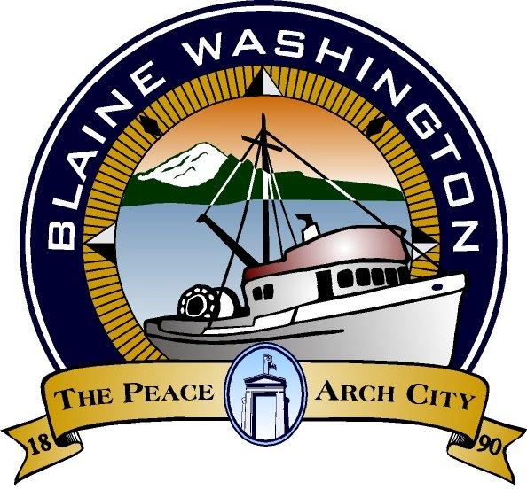
CITY OF BLAINE
344 H Street
Blaine, WA 98230
CITY COUNCIL AGENDA

Monday, April 26, 2004, 7:00 PM

WELCOME
'YOUTH IN GOVERNMENT DAY'

NOTE: WORK SESSION - 5:15 p.m. Comprehensive Plan Update

A. EXECUTIVE SESSION: -See End of Meeting

- CALL TO ORDER

- INVOCATION – MOMENT OF SILENCE

- PLEDGE OF ALLEGIANCE

- ROLL CALL:

- STAFF PRESENT:

B. AUDIENCE PARTICIPATION
(Participants will be allowed 3 minutes to speak)

- Teen Court Presentation - Commissioner Chuck Snyder
- Appreciation for Volunteers
- Bruce and Sandy Wolf Bell-Road Sign Landscaping
- George Kaas and Students Martin Street End

C. CITY MANAGER AND STAFF REPORTS

- First Quarter Financial Report - Meredith Riley
- City Hall Building Improvement Plan Report - Steve Banham
- Report First Quarter Building Starts/Development - Terry Galvin
- Neighborhood Meeting for 6th Street Tree Planting Project - Terry Galvin
- Adelia Street Meeting Report - Terry Galvin

- MAYOR’S REPORT

E. WRITTEN COMMUNICATIONS

F. CONSENT AGENDA
Items listed below have been distributed to Council members in advance for study and will be enacted by one motion. If separate discussion is desired on an item, that item may be removed from the Consent Agenda and placed on the Regular Agenda at the request of a Councilmember.

- Approval of Bills - Amount: $

- Approval of March Payroll: $331,146.03

- Approval of April 12, 2004 City Council Minutes

- Approval of Proclamation for Blessing of the Fleet

G. PUBLIC HEARING (MEETING)
*PLEASE NOTE: Persons speaking on any issue will be allowed three (3) minutes. An additional two (2) minutes of non-repetitive testimony will be allowed after all testimonies have been heard

NONE

H. UNFINISHED BUSINESS

NONE

I. NEW BUSINESS
-
- Semiahmoo Electrical Loop Feeder Project Contract Award. First Reading

- Washington State Department of Transportation (WSDOT) purchase of access rights of airport property along Boblett Street SR 543 - SR5 to International Boundary - First Reading.

- Street Overlay Paving - First Reading.

- Ordinance No. 04-2576 Adding other sewer improvement payment contracts to BMC 13.14.100 for conservation and efficiency. First Reading

- Interlocal Agreement Purchasing Agreement between Cities of Blaine, Everson, Ferndale, Lynden, Sumas, Nooksack and Whatcom County. First Reading.

J. COUNCIL MEMBERS AND ADVISORY COMMITTEE REPORTS

K. FURTHER BUSINESS

L. EXECUTIVE SESSION - 42.30.110 (i) Potential Litigation

M. ADJOURN

Americans with Disability Act (ADA) Requirement: The meeting location is accessible. If you require a special accommodation during your attendance at any public meeting, please contact the City Clerk (360) 332-8311, 7 – 10 days prior to the meeting date you will be attending. Thank you.

