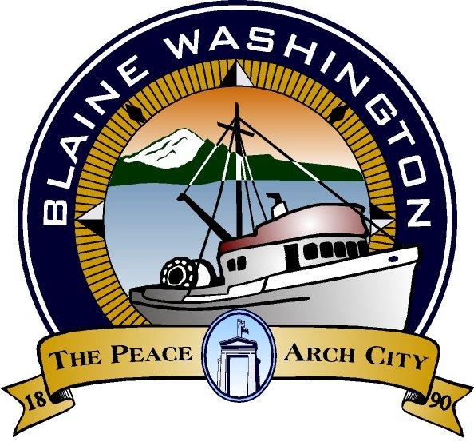

344 H Street, Blaine WA 98230

CITY COUNCIL
WORKSESSION

MONDAY, October 17, 2005

5:30 PM

John Liebert - Mayor

A. CALL TO ORDER:

B. ROLL CALL: Brunkow, Ely, Hawkins, Liebert, Myers, Onyon, Wolf

C. BUSINESS

- Seagrass

D. ADJOURN

