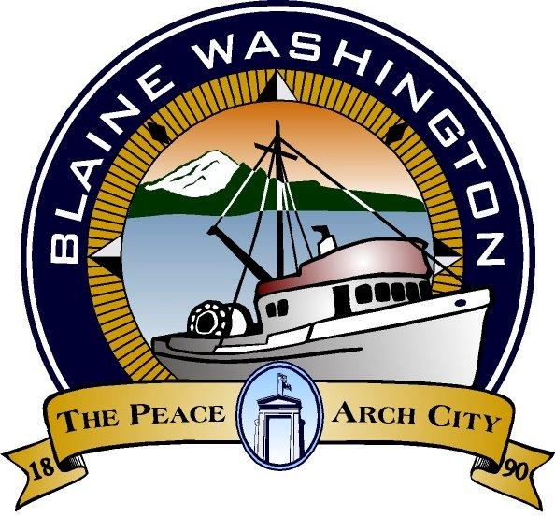

344 H Street, Blaine WA 98230

CITY COUNCIL
WORKSESSION

MONDAY, August 1, 2005

6:15 PM

John Liebert - Mayor

A. CALL TO ORDER:

B. ROLL CALL: Brunkow, Ely (excused), Hawkins, Liebert, Myers (excused), Onyon, Wolf

C. BUSINESS

- Alternative Land Use

D. ADJOURN

