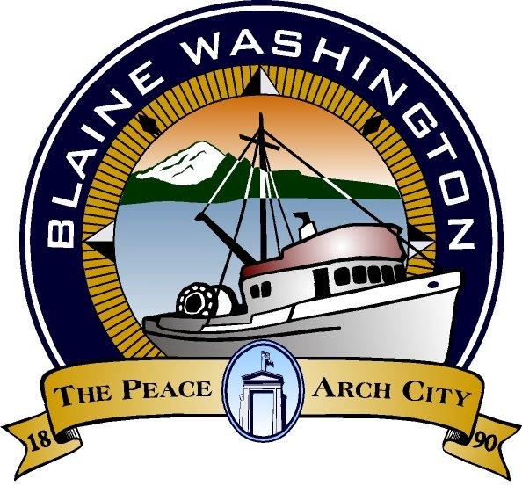

344 H Street, Blaine WA 98230

CITY COUNCIL
WORKSESSION

MONDAY, July 18, 2005

5:15 PM

John Liebert - Mayor

A. CALL TO ORDER:

B. ROLL CALL: Brunkow, Ely, Hawkins, Liebert, Myers, Onyon, Wolf

C. BUSINESS

- Seagrass Subdivision

D. ADJOURN

