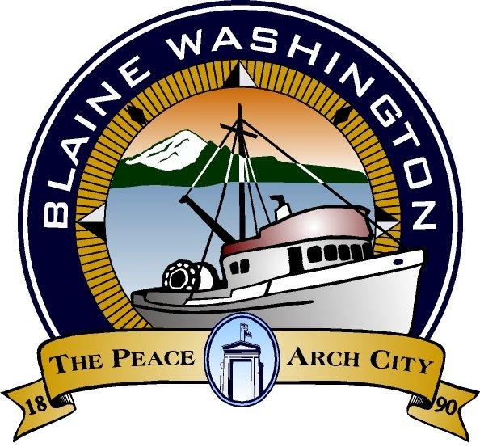

CITY OF BLAINE
435 Martin Street, Suite 4000
Blaine, WA 98230

CITY COUNCIL
STUDY SESSION

Monday, November 16, 2015
5:00 PM

A. CALL TO ORDER:

Councilmembers:
Paul Greenough, Charlie Hawkins, Steve Lawrenson, Dennis Olason, Bonnie Onyon, Harry Robinson, and Mary Lou Steward.

- BUSINESS:
- 2016 Budget

- ADJOURNED:

Americans with Disability Act (ADA) Requirement: The meeting location is accessible. If you require a special accommodation during your attendance at any public meeting, please contact the City Clerk (360) 332-8311, 24 hours prior to the meeting date you will be attending. Thank you.

