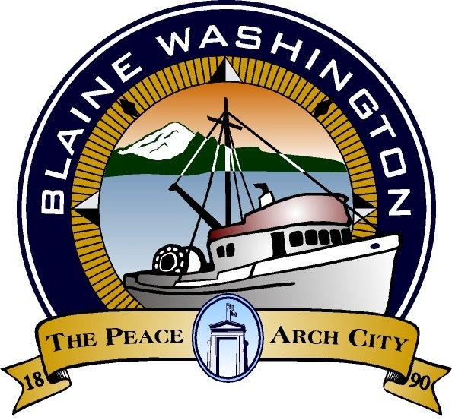

CITY OF BLAINE
435 Martin Street, Suite 4000
Blaine, WA 98230
SPECIAL CITY COUNCIL AGENDA

Monday, November 20, 2017
6:30 PM

- STUDY SESSION – 6:00 PM – 2018 Budget

- CALL TO ORDER:

ROLL CALL:
Councilmembers: Charlie Hawkins, Meg Olson, Bonnie Onyon, Steve Lawrenson, Paul Greenough, and Harry Robinson. Mary Lou Steward requested to be excused.

- EXECUTIVE SESSION – approximately 6:30 PM – to discuss sale of real property pursuant to RCW 42.30.110(1)(c)

- ADJOURNED:

Following the council meeting, the council will convene in closed session to discuss collective bargaining pursuant to RCW 42.30.140(4)(b)

Americans with Disability Act (ADA) Requirement: The meeting location is accessible. If you require a special accommodation during your attendance at any public meeting, please contact the City Clerk (360) 332-8311, 24 hours prior to the meeting date you will be attending. Thank you.

