+

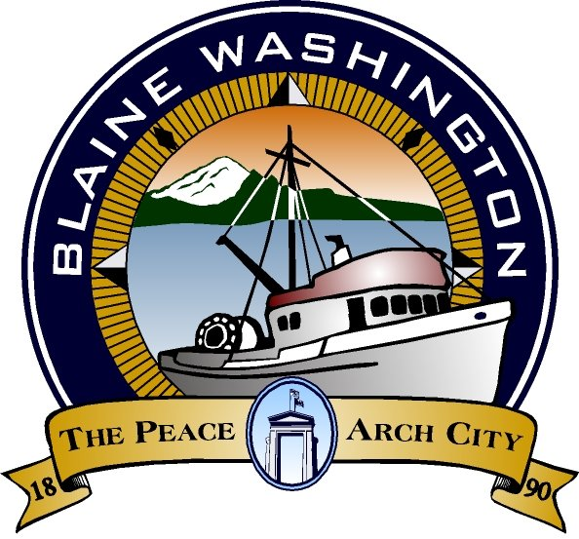
CITY OF BLAINE
435 Martin Street, #3000 • BLAINE, WA 98230
BUS: 360.332.8311 • FAX: 360.332.8330 • www.cityofblaine.com

VOUCHER MEMO

January 14, 2022

To: City Council
From: Ashley Noland, Accounting Technician
Subject: January 18 Council Meeting Vouchers for Approval

Payables of interest are as follows:

2nd Open Period 2021 Vouchers:

- Northwest Ecological Services – Environmental review of Skate Park - $6,075.00
- State Auditor’s Office – December Financial Audit - $5,202.60
- VECA Electric – Various city projects, pumps, work in well field - $24,807.10
- Wilson Engineering – Lift Station #3 and #10 Improvements - $26,611.15

