Fire District Month End Administrative Report for February 2021:

Date: March 2021
To: NWFR & WCFD#4 Board of Commissioners
From: Fire Chief Jason Van der Veen
Subject: February 2021 Chiefs Report

Probationary Firefighter Update:
All the progress reports from the Recruit Academy have been excellent. They continue to be top ranked in their class and have each shown improvement in their skills and leadership. They are certainly making me proud!

Seth Meredith, the probationary firefighter who had previously attended the Academy, has completed his onboard shift training, and is currently working a regular shift.

COVID-19 Vaccinations
Operational members of the department have been offered the Covid-19 vaccine. The vaccination clinics have been arranged by the County Health Department. Vaccinations are completely voluntary.

Regional Fire Authority Planning
Our first two public outreach sessions happened on February 18th and 23rd. We had some good questions asked by the public at both sessions. Our special work session held on February 25th was well received and opened some great conversations.

Paramedics Graduate – 1st NWFR Graduates
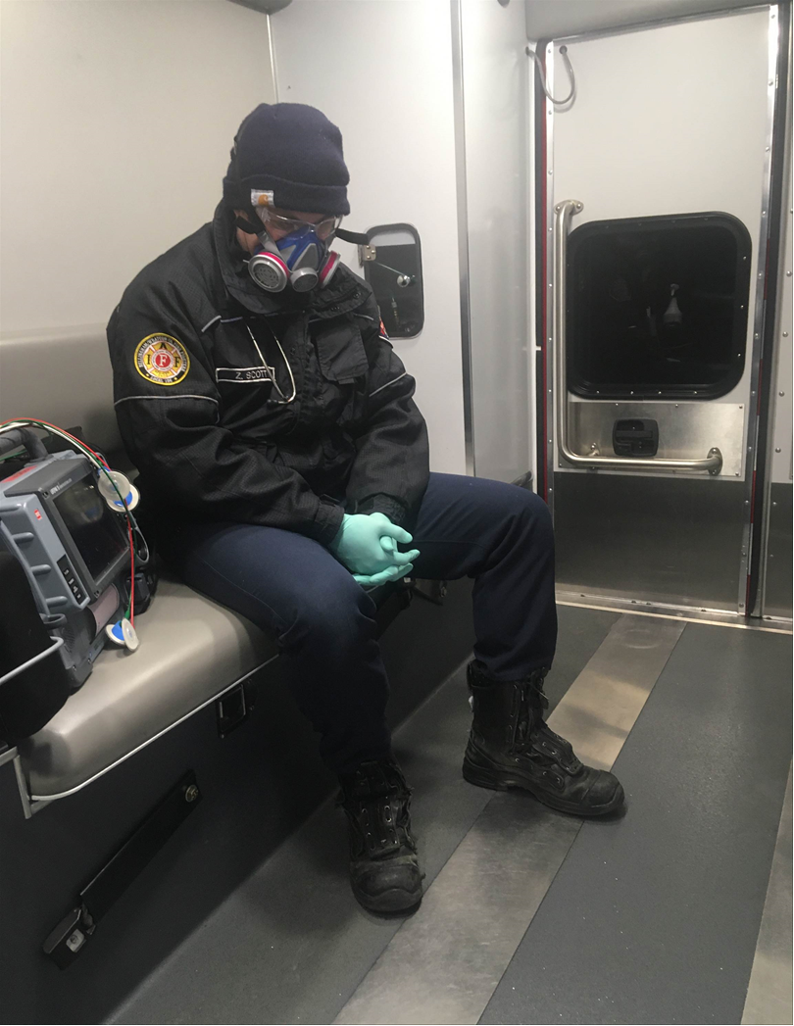
Our 2020 Paramedic students have both graduated and transferred to Bellingham Fire Department on March 1st. Zach Scott started as a volunteer 2014 and became a career member in 2016. Sean Roberts started as a career member in 2017. We wish them both luck and are excited to see some familiar faces serving as Medics.

The 2021 Paramedic class just started mid-February. David Comp and David Hancock are the two NWFR students in the class.

Respectfully Submitted,

Jason Van der Veen

Operations Division Report

Crew Activities
- Visited the recruits at North Bend Fire Training Academy. All three are doing well.
- Finished our in-house Officer course (Officer I, Officer II, ISO, Strategies and Tactics) (Lead trainer- Lt. Hofstad). These training classes are for firefighters who wish to test for officer roles in the department.
- B76 - Mutual Aid structure fire in Lynden, E69, E63, 3.4.2021, great job by all personnel who assisted.

Operations Projects / Meetings
- County Operations Zoom meeting - New Stryker power gurney delivery coming in late March. Vendor will do all install of the mounting brackets in our first out units.
- County Training Officers meeting – Review of 1st quarter Rescue Hub and EMS Connect
- Operative IQ continuation and training of new personnel to assist in the implementation and entering of inventory data.
- Attended Zoom pinning for Paramedic Zach Scott.
- Improve communication with Shop to support members when one of the tenders is taken for service.
- Lighting security for St. 63 and 72 now complete.
- EMS Committee is up and running for the department to ensure EMS training is complete and evaluations done in a timely manner.
- Attended WCEMS council planning meeting, (Zoom)
- Attended Training Consortium meeting, St 31.
- Assisted Chief with data gathering for the RFA process.
- Completed final inspection of the two new Road Rescue Ambulances in Orlando FL.

Total February Calls 391

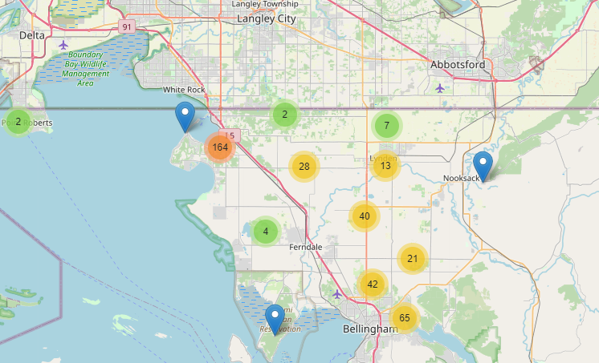

New ambulance at factory. Delivery April 2021

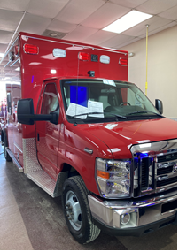
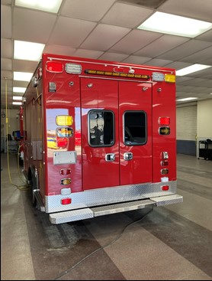

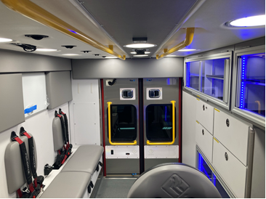

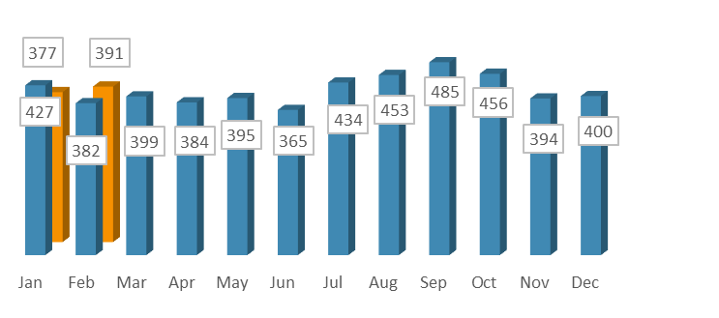
NWFR Incidents by Month 2020-2021

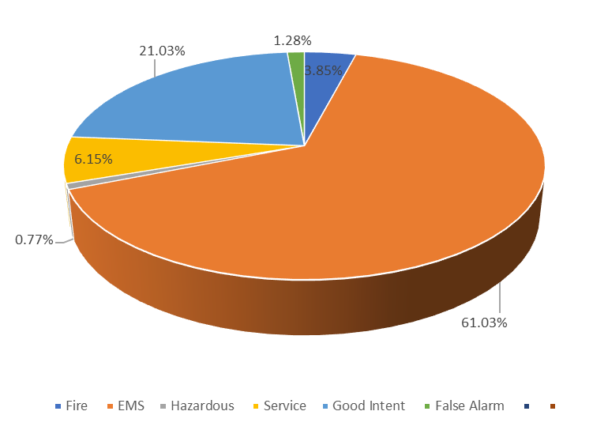

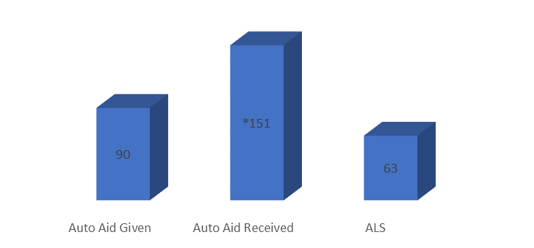
Month End Response Summary

Aid Given and Received
*Includes ALS Responses

Fire Marshal Report

- Public Education (None due to COVID-19)
- Engine Company Inspections 5 (Reduced numbers due to COVID-19)

Total fire calls = 15
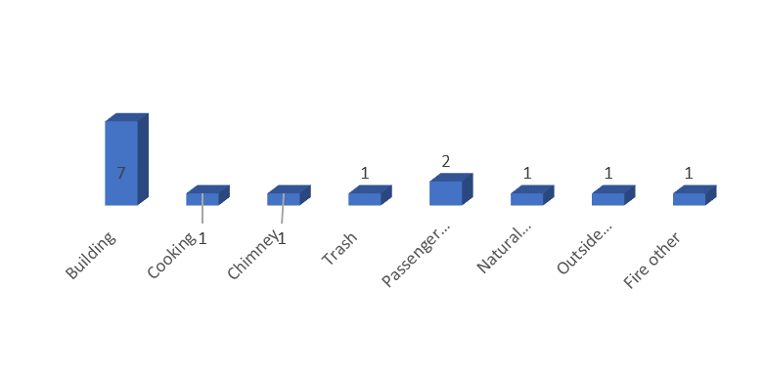Fire Incident Type

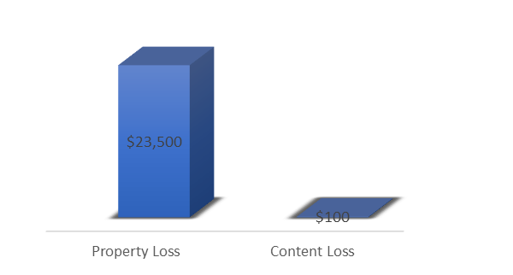

Fire Loss

