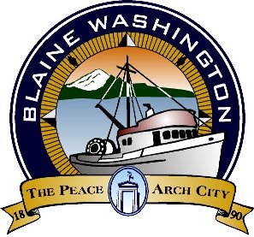

**Blaine Tourism Advisory Committee**

**MINUTES**

City Hall Council Chambers, 435 Martin Street, Suite 4000 www.ci.blaine.wa.us (360) 332-8311

**Wednesday, November 24, 2020**

**Called to order at 8:00 AM**

**Roll Call**: Eric Davidson, Bob Boule, Debby Farmer, Louise Mugar, Liz Thorton (absent), Sukhwant Singh Gill , and Annette Bagley (absent).

**Staff** **Present**: Alex Wenger, Economic Development and Tourism Coordinator; Stacie Pratschner, Community Development Services Director

**AUDIENCE COMMENTS**

**NEW BUSINESS**

* Board members continued their discussion of the 2021 BTAC grant applications and proposed 2021 budget. Presentations for grant applications were given at the October 20, 2020 meeting.

**MOTION MADE BY MS. MUGAR TO APPROVE THE 2021 BUDGET AS PROPOSED. SECONDED BY MR. GILL. MOTION PASSES (4-1).**

**APPROVAL OF MINUTES**

* November 10, 2020;
* November 17, 2020.

**ADDITIONAL INFORMATION**

* Next meeting scheduled for Tuesday January 12, 2020.

**Adjourned 8:45 AM.**