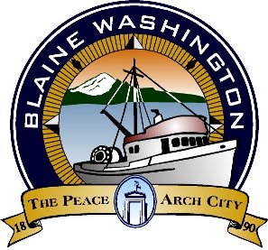

**Blaine Tourism Advisory Committee**

**MINUTES**

City Hall Council Chambers, 435 Martin Street, Suite 4000 www.ci.blaine.wa.us (360) 332-8311

**Wednesday, November 17, 2020**

**Called to order at 8:03 AM**

**Roll Call**: Eric Davidson, Bob Boule, Debby Farmer, Louise Mugar, Liz Thorton (absent), Sukhwant Singh Gill (absent), Sandy Baker (absent) and Annette Bagley (absent).

**Staff** **Present**: Alex Wenger, Economic Development and Tourism Coordinator; Stacie Pratschner, Community Development Services Director

**AUDIENCE COMMENTS (none)**

**NEW BUSINESS**

* Board members continued their discussion of the 2021 BTAC grant applications. Presentations for grant applications were given at the October 20, 2020 meeting.

**APPROVAL OF MINUTES**

Minutes were not provided**.**

**ADDITIONAL INFORMATION**

* Next meeting scheduled for Tuesday November 24, 2020

**Adjourned 9:35 AM.**