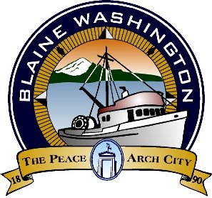

**Blaine Tourism Advisory Committee**

**MINUTES**

City Hall Council Chambers, 435 Martin Street, Suite 4000 www.ci.blaine.wa.us (360) 332-8311

**Wednesday, November 10, 2020**

**Called to order at 8:04 AM**

**Roll Call**: Eric Davidson, Bob Boule, Debby Farmer, Louise Mugar, Liz Thorton (absent), Nicole Newton, Sukhwant Singh Gill, Sandy Baker (absent) and Annette Bagley (absent).

**\*Mr. Gill arrived after the meeting was called to order.**

**Staff** **Present**: Alex Wenger, Economic Development and Tourism Coordinator; Stacie Pratschner, Community Development Services Director

**AUDIENCE COMMENTS (none)**

**NEW BUSINESS**

* Community Development Services introduced the Preliminary City Lodging Tax Budget for 2021. Board members asked questions and had a discussion.
* Chairman of the board opened discussion for review of the BTAC grant applications. Presentations for grant applications were given at the October 20, 2020 meeting. Board members had a discussion.

**APPROVAL OF MINUTES**

**MOTION TO APPROVE OCTOBER 20, 2020 MINUTES BY MRS. FARMER. SECONDED BY MR. BOULE. APPROVED UNANIMOUSLY.**

**ADDITIONAL INFORMATION**

* Next meeting scheduled for November 17, 2020.

**Adjourned 9:47 AM.**