Blaine City Council Retreat 2020

To: Michael Jones, MPA / City Manager  
From: Stacie Pratschner, AICP, RPA / Community Development Services Director  
Date: February 20, 2020  
**Re: Community Development Services Executive Summaries**

# Summary

The Community Development Services Department (CDS or “the Department”) is providing this memorandum in advance of the City of Blaine Council Retreat scheduled for March 2, 2020. The purpose of this memo is to provide Executive Summaries of all the following Plans that the Department implements through municipal code; development review; and long range planning:

* **The 2016 Comprehensive Plan**
* *Vision Statement*
* *The Elements*
  + - Population
    - Housing
    - Economic Development
    - Land Use
    - Transportation
    - Utilities;
    - Public Facilities
    - Parks and Recreation
    - Environment
* *The Appendices*

- Capital Facilities

- The Resort Semiahmoo Master Plan

- The Wharf District Master Plan

* **The 2019 Tourism Development and Marketing Plan**
* **The 2019 Shoreline Master Program**
* **The Non-Motorized Transportation Plan**
* **The East Blaine Infrastructure Plan**

Where available, summaries have been copied from the subject Plan and accompanied by a web page link. Plans lacking executive summaries have been synopsized by CDS.

# The 2016 Comprehensive Plan

*No Executive Summary: See synopsis below*

The purpose of the 2016 Comprehensive Plan is to consider specific planning goals that facilitate population and employment growth when developing land use policy and regulations.[1] These goals include but are not limited to control of urban sprawl; encouraging efficient transportation systems; promoting economic development; maintaining the natural environment; and ensuring adequate public facilities. The city’s Comprehensive Plan is consistent with the local planning framework of the Countywide Planning Policies, and the Plan’s goals and policies are implemented through the Blaine Municipal Code (BMC) at the time of development permit review.

# Vision Statement

[*https://www.ci.blaine.wa.us/DocumentCenter/View/12283/0-Vision-Statement-FINAL-5-18-16?bidId=*](https://www.ci.blaine.wa.us/DocumentCenter/View/12283/0-Vision-Statement-FINAL-5-18-16?bidId=)

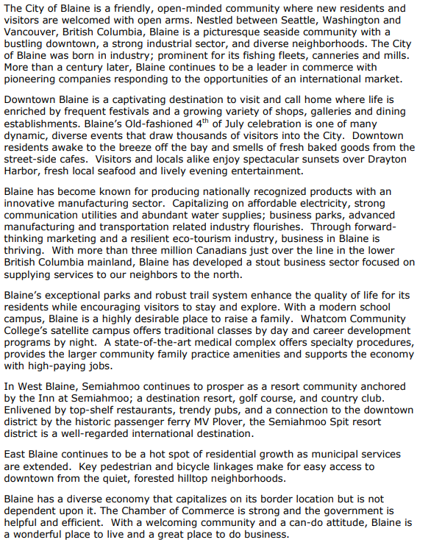

# The Population Element

[*https://www.ci.blaine.wa.us/DocumentCenter/View/12283/0-Vision-Statement-FINAL-5-18-16?bidId=*](https://www.ci.blaine.wa.us/DocumentCenter/View/12283/0-Vision-Statement-FINAL-5-18-16?bidId=)

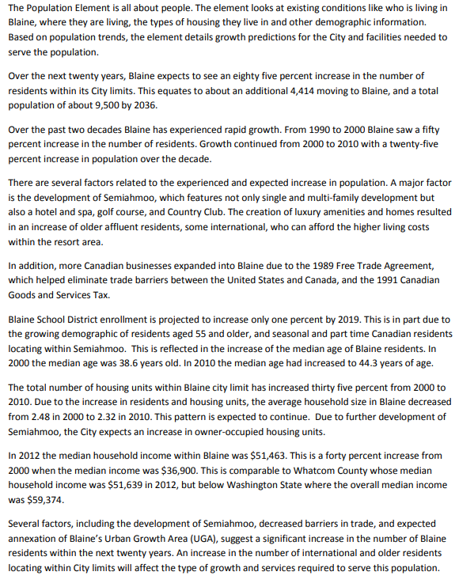

# The Housing Element

[*https://www.ci.blaine.wa.us/DocumentCenter/View/12326/Housing-Element?bidId=*](https://www.ci.blaine.wa.us/DocumentCenter/View/12326/Housing-Element?bidId=)

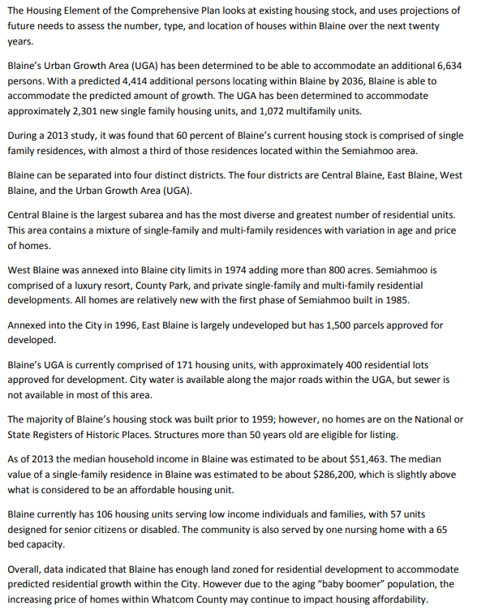

# The Economic Development Element

[*https://www.ci.blaine.wa.us/DocumentCenter/View/12327/Economic-Development-Element?bidId=*](https://www.ci.blaine.wa.us/DocumentCenter/View/12327/Economic-Development-Element?bidId=)

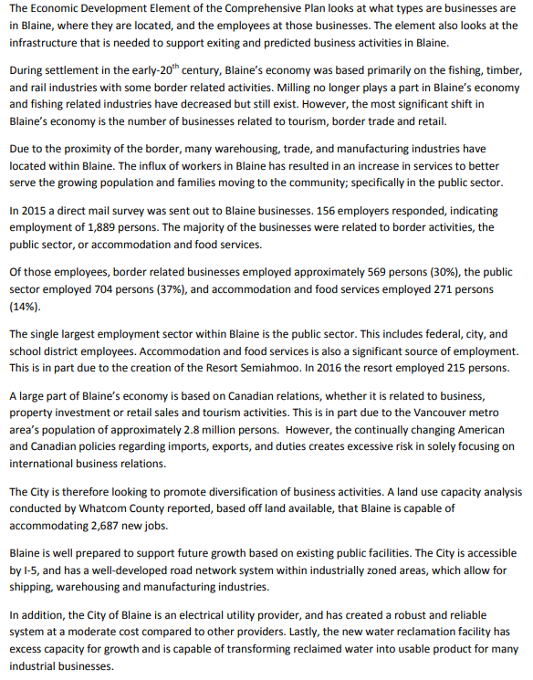

# The Land Use Element

[*https://www.ci.blaine.wa.us/DocumentCenter/View/12328/Land-Use-Element?bidId=*](https://www.ci.blaine.wa.us/DocumentCenter/View/12328/Land-Use-Element?bidId=)

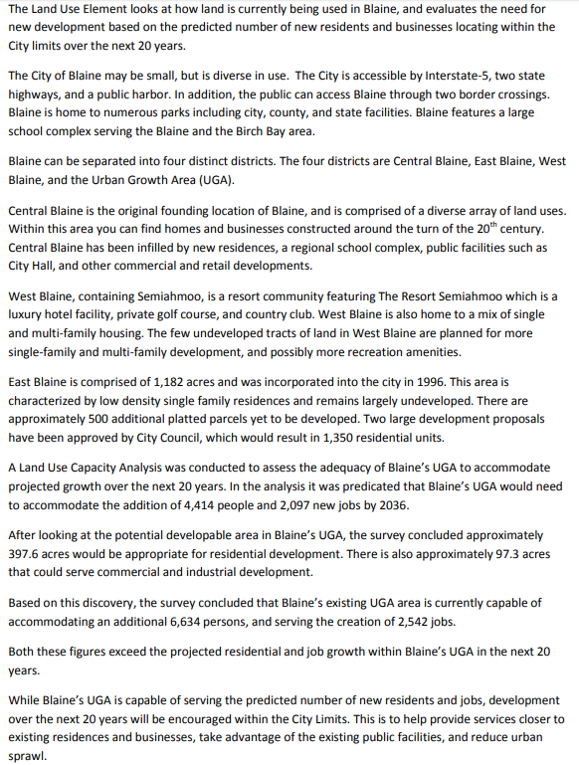

# The Transportation Element

[*https://www.ci.blaine.wa.us/DocumentCenter/View/12329/Transportation-Element?bidId=*](https://www.ci.blaine.wa.us/DocumentCenter/View/12329/Transportation-Element?bidId=)

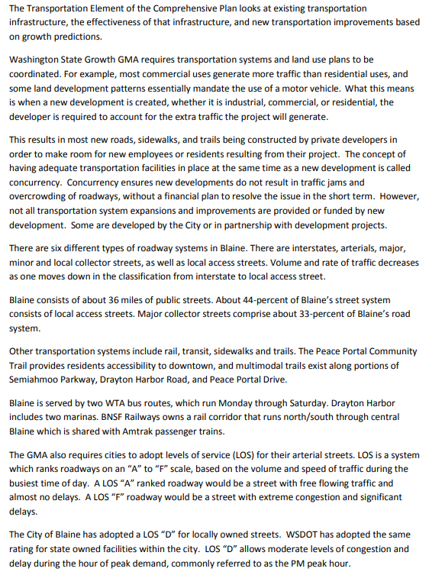

# The Utilities Element

[*https://www.ci.blaine.wa.us/DocumentCenter/View/12330/Utilities-Element?bidId=*](https://www.ci.blaine.wa.us/DocumentCenter/View/12330/Utilities-Element?bidId=)

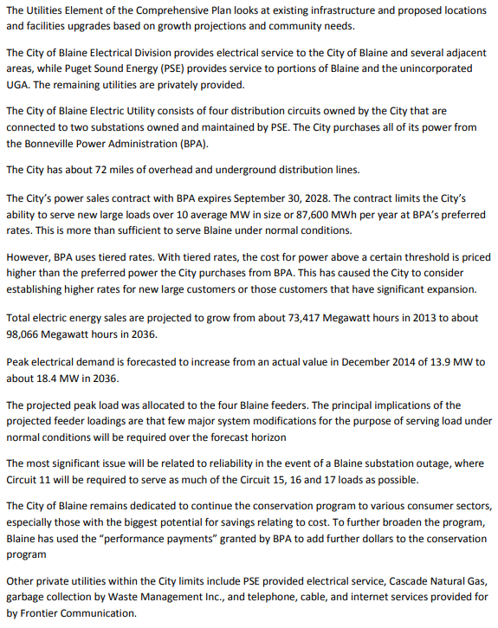

# The Public Facilities Element

[*https://www.ci.blaine.wa.us/DocumentCenter/View/12331/Public-Facilities-Element?bidId=*](https://www.ci.blaine.wa.us/DocumentCenter/View/12331/Public-Facilities-Element?bidId=)

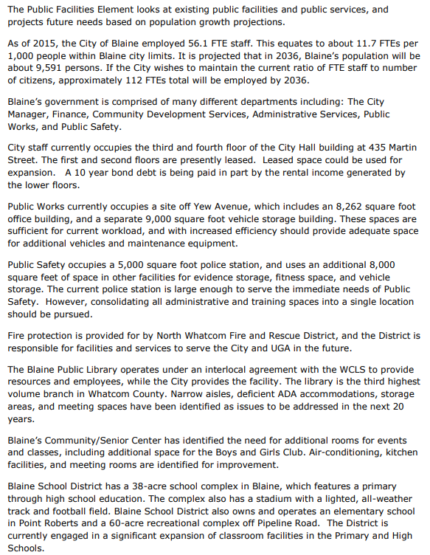

# The Park and Recreation Element

[*https://www.ci.blaine.wa.us/DocumentCenter/View/12332/Park-and-Recreation-Element?bidId=*](https://www.ci.blaine.wa.us/DocumentCenter/View/12332/Park-and-Recreation-Element?bidId=)

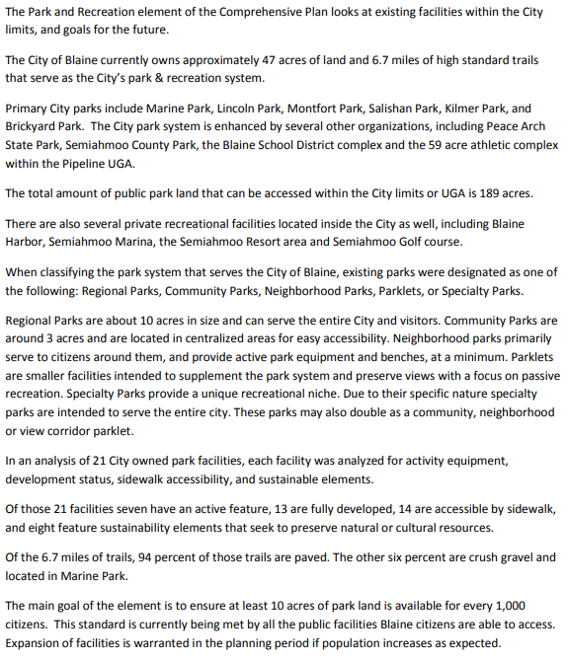

# The Environment Element

[*https://www.ci.blaine.wa.us/DocumentCenter/View/12335/Environment-Element?bidId=*](https://www.ci.blaine.wa.us/DocumentCenter/View/12335/Environment-Element?bidId=)

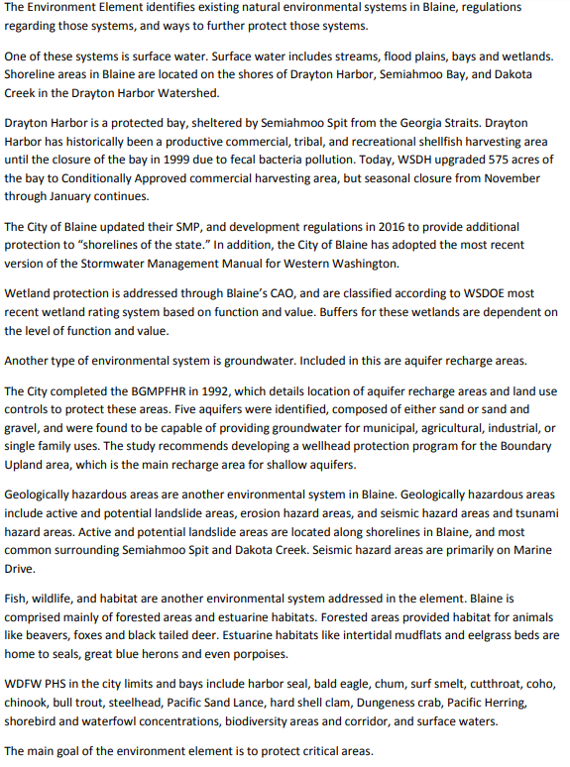

# The Capital Facilities Plan

[*https://www.ci.blaine.wa.us/DocumentCenter/View/12303/FINAL-Appendix-A-Capital-Facilities?bidId=*](https://www.ci.blaine.wa.us/DocumentCenter/View/12303/FINAL-Appendix-A-Capital-Facilities?bidId=)

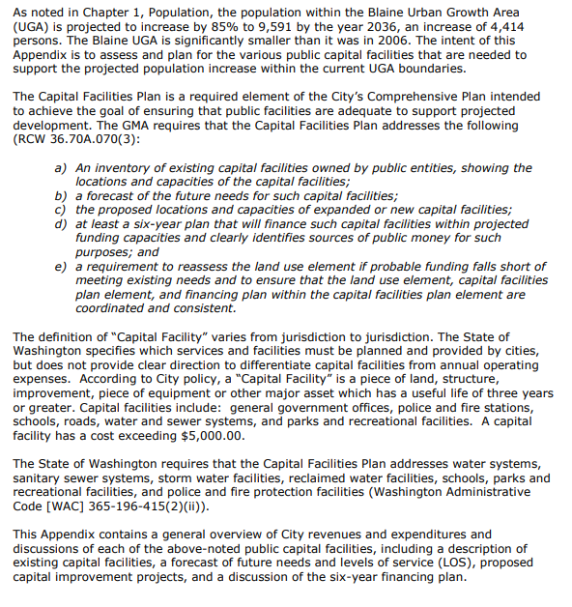

# The Resort Semiahmoo Master Plan (2014)

*No Executive Summary: see synopsis below*

The RSMP provides an overall framework for land use development; landscaping; traffic and transportation; utilities; public facilities and services; and implementation for Semiahmoo uplands and Spit. The RSMP acknowledges that the Semiahmoo area is a “town within a town”, whose purpose to serve as a planned resort community is complemented by the development of tourism and recreation opportunities. The Plan includes design and bulk and dimensional standards; and a transportation study with proposed mitigation for the anticipated 200 + additional homes that may be constructed over the six-year planning horizon.

# The Wharf District Master Plan (2007)

# [*https://www.ci.blaine.wa.us/DocumentCenter/View/13724/Wharf-District-Mstr-Pln-BlaineCompPlanAppendix_C?bidId=*](https://www.ci.blaine.wa.us/DocumentCenter/View/13724/Wharf-District-Mstr-Pln-BlaineCompPlanAppendix_C?bidId=)

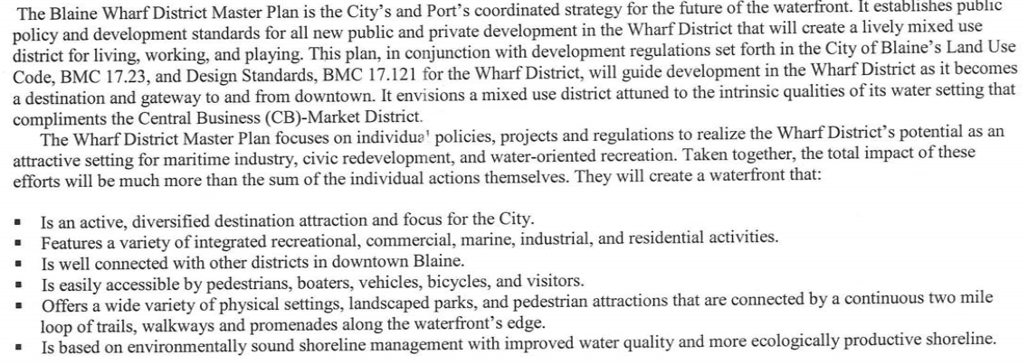

# The 2019 Tourism Development and Marketing Plan

[*https://www.ci.blaine.wa.us/DocumentCenter/View/450/Blaine-Tourism-Marketing--Development-Plan?bidId=*](https://www.ci.blaine.wa.us/DocumentCenter/View/450/Blaine-Tourism-Marketing--Development-Plan?bidId=)

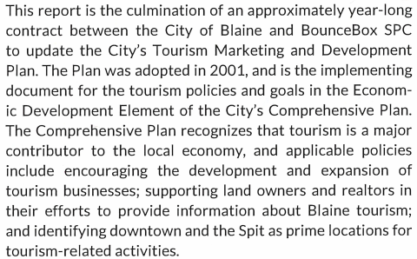

# The 2019 Shoreline Master Program

*No Executive Summary; see synopsis below*

In 1972, Washington State voters approved the Shoreline Management Act[2] by public referendum. The Act established the following three broad policy goals: 1) Protection of shoreline natural resources; 2) promotion of public access and enjoyment; and 3) the encouragement of water-dependent uses. The City of Blaine implements these State mandates through its Shoreline Master Program, which establishes design and bulk and dimensional standards for developments proposed within 200 feet of the ordinary high water mark (OHWM) of regulated marine; riverine; or lacustrine environments. The Plan establishes the legal, factual, and procedural requirements for shoreline permits, including substantial developments; conditional uses; and variances.

# The Non-Motorized Transportation Plan (2009)

[*https://www.ci.blaine.wa.us/DocumentCenter/View/3221/Non-Motorized-Transportation-Plan-2-9-09?bidId=*](https://www.ci.blaine.wa.us/DocumentCenter/View/3221/Non-Motorized-Transportation-Plan-2-9-09?bidId=)

# City of Blaine East Blaine Infrastructure Plan (2009)

[*https://www.ci.blaine.wa.us/DocumentCenter/View/3220/E-Blaine-Infrastr-Plan---final?bidId=*](https://www.ci.blaine.wa.us/DocumentCenter/View/3220/E-Blaine-Infrastr-Plan---final?bidId=)

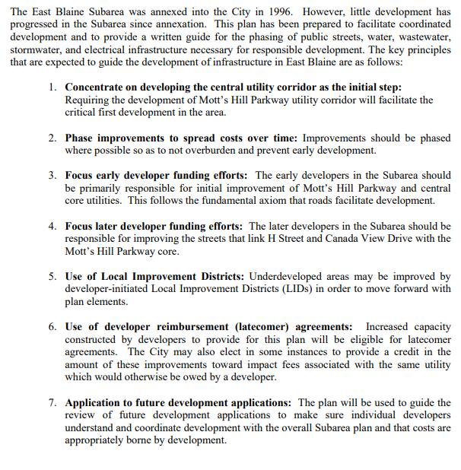

1. RCW 36.70A.210: The Washington State Growth Management Act
2. Title 90.58 of the Revised Code of Washington (RCW).