CITY OF BLAINE
BLAINE ECONOMIC DEVELOPMENT ADVISORY COMMITTEE AGENDA
“Revenue Task Force”

Tuesday, May 2, 2017
3:00 PM
City Council Chambers

- CALL TO ORDER:

- ATTENDANCE:

- WRITTEN COMMUNICATION:
  - None

- APPROVAL OF MINUTES:

- NEW AGENDA ITEMS:
  - Economic Development Updates
  - Revenue Task Force - The “Revenue Task Force Draft Work Plan” is the last page of this agenda packet

- NEW BUSINESS

- HOLD – IN PROGRESS

- ADJOURN
Americans with Disability Act (ADA) Requirement: The meeting location is accessible. If you require a special accommodation during your attendance at any public meeting, please contact the Administrative Services Department (360) 332-8311, 24 hours prior to the meeting date you will be attending. Thank you.

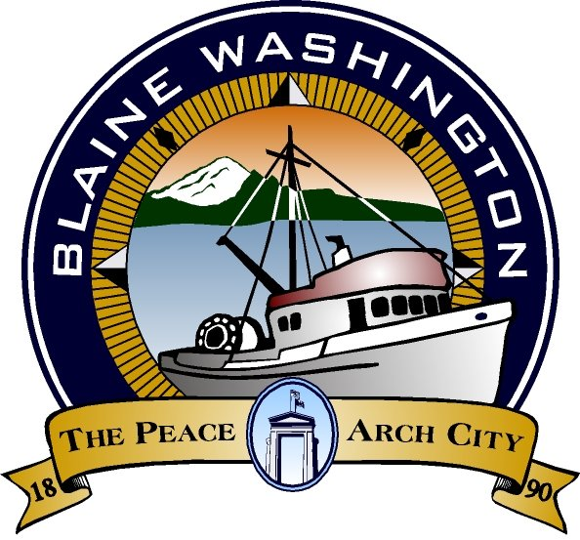
CITY OF BLAINE
435 MARTIN ST., SUITE 3000 • BLAINE, WA 98230-4109
BUS: 360.332.8311 • FAX: 360.332.8330 • www.cityofblaine.com

April 28, 2017

As you know, the City of Blaine has developed a Strategic Economic Initiative (SEI) to identify a strategy and priorities for City services and projects. In all, 933 responses were received through public meetings, surveys and focus groups. You were an important part of that process, and we want to thank you for participating. The final phase of that work will occur this summer.

The first outcome from the SEI was to place a 0.2% (two tenths of one percent) sales tax increase on the April Special Election ballot to fund street and trail improvements. The unofficial ballot return shows the TBD passing with 72% support. That’s a major accomplishment that demonstrate how positive citizens feel about the City.

The next step is to assemble a Revenue Task Force (RTF) to provide a recommendation for the Blaine City Council on how to fund programs and services local residents want. Thank you for your willingness to serve on the Revenue Task Force.

The RTF is unique in that there will only be four meetings during the month of May. Our goal is to teach community leaders about the services offered by the City; budgeting constraints to meet these demands; and options for future revenue. The final meeting will result in a recommendation to City Council about revenue options to be included in the 2018 Budget.

Like most cities, the demand for services is higher than the revenue available to provide them. In prior years, we have made cuts to maintain a balanced budget and drawn down reserves, which is not sustainable.

The City is limited by law to a one percent revenue increase per year on its property tax levy. It also retains less than one percent of the 8.5% sales tax remitted to the state. This is causing the City to look at different ways to fund the services and projects that local residents want.

The meetings will take place May 2, 9, 16 and 23 from 3:00 pm to 5:00 pm. We are honored to have you take part in our commitment to improve the Blaine community.

Thank you in advance for your time and consideration,

David Wilbrecht
City Manager

